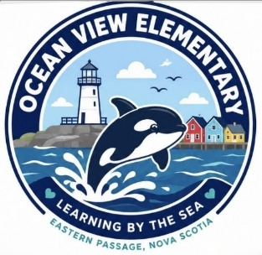
Ocean View Elementary
Grade 1 Suggested Supply List 2026-27

- 4 duo-tangs - any colour
- 40 sharpened pencils
- 2 plastic two-pocket folders (red, blue)
- 4 white erasers
- 2 box of 24 crayons (Crayola is suggested)
- 2 boxes of 8 washable thick markers (Crayola broad line is suggested)
- 1 box of 24 colored pencils (pencil crayons)
- 4 six-packs of thin dry-erase whiteboard markers
- 2 large glue sticks
- 2 small glue sticks
- 1 pair of children’s scissors
- Headphones for computer use (labeled with name)
- 1 large box of zippered baggies
- 1 Package of 4 32-page scribblers (such as Hilroy)
- 2 (72 page) half plain, half ruled small exercise books (such as Hilroy)
- 1 plastic Kit Box
- 2 Large zippered vinyl bags. They have a plastic label holder on the front (found only at Dollarama) NOT MESH/RAINBOW

Your student should also have:
- Indoor Sneakers suitable for Physical Education (to be kept at school)
- A change of clothes, in a labelled ziplock bag to be kept at school
- A water bottle (to be taken home each day)

Optional:
- Kleenex
- Package of unscented baby wipes

