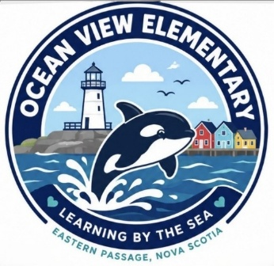
Ocean View Elementary
Grade 2 School Supply List 2026-2027

*Please label supplies and take them out of packaging. (Individual pencils, markers, crayons do not need to be labeled)

1 - large Kit Box (plastic - the long one)
4 - regular paper duo-tangs (suggested colors - red, green, yellow, blue)
2 - plastic twin pocket folders
2 - plastic twin pocket folder with tangs
4 - white erasers
24 - pencils (ALL sharpened)
1 – personal pencil sharpener (with container attached to collect shavings)
1 - pair of metal scissors
2 - packages of 24 crayons
1 - package of 24 coloured pencils (ALL sharpened)
2 - boxes of THICK markers
2 - black permanent markers (e.g. sharpies)
6 - large glue sticks
1 – bottle of white liquid glue
2 - yellow “exercise books”- (1⁄2 lined, 1⁄2 blank - 72 pages)
2 - green “exercise books”- (1⁄2 interlined, 1⁄2 blank - 72 pages)
4 - scribblers (40 pages each) (no coils please)
16 - whiteboard (dry erase) markers
1 - zippered pouch (legal size – 8x14 – available at Dollarama)
1 - set of headphones
1 - pair of labelled indoor shoes with non-marking soles

Optional:
If you are able, our classroom would welcome donations of:
- boxes of tissues - classes go through 1 or 2 boxes of tissue per week, so we welcome donations all throughout the year, if possible.
- large ziploc-type bags
- baby wipes
- additional whiteboard (dry erase) markers – students use them daily for both math and language arts. We run out often, so if you are able to donate more it would be greatly appreciated.

PLEASE PUT THE FOLLOWING ITEMS FROM THE ABOVE LIST IN THE KIT BOX:
3 sharpened pencils, sharpener, 1 white eraser, scissors, 1 glue stick, 1 whiteboard marker, crayons and markers *The remaining items can be packaged in a large ziplock-type bag labelled with your child’s name.

