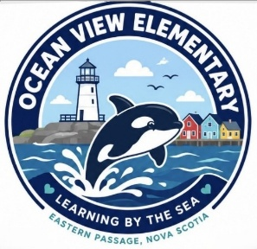
Ocean View Elementary
Grade Primary Suggested Supply List 2026-27

2 Half lines/half blank (Hilroy) green scribbler
20 Regular Pencils (sharpened)
3 Large glue sticks
2 Boxes of 24 Crayons
1 pack 24 Pre-Sharpened Coloured Pencils
1 Plastic pencil box (labelled)
4 Containers of Play-Doh (regular size)
1 pack of 4 32-page Exercise books (Scribblers)
1 pencil sharpener (with plastic container for shavings)
2 Box Washable Broad Line Markers, 10 count
1 Pair of Scissors (Kids Soft grip Scissors)
1 White Erasers
8 White Board Markers black/blue (for student use)
4 duo tang, 2-Pocket Folders (1 each of orange, blue, green, yellow if possible)
1 Large zippered vinyl bag (not mesh) for home message bag. They have a plastic label holder on the front (can be found at Dollarama)
1 Pair of labelled sneakers for indoors to be left at school. (Please only send laced sneakers if your child is able to quickly tie independently)
2 Large Ziplock bags
1 Spare change of clothes including socks and underwear in a labelled Ziploc bag to be kept in school bag
1 Refillable water bottle which will go home each day

It would be extremely beneficial if you purchased no themed supplies. Fancy erasers and pencils tend to be a distraction and usually of lower quality when compared to standard supplies.

Any donations of facial tissue, baby wipes [unscented], and/or large Ziploc bags, play doh for the classroom would be greatly appreciated.

