Welcome to our new Trackit Helpdesk system.
For Teachers and Administration staff: https://helpdesk.hrsb.ns.ca/TrackIt/SelfService/Account/LogIn
Sign in with the username example listed below: <USERNAME HERE> and password: support

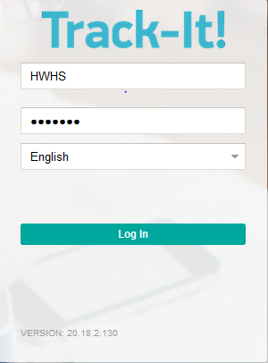

Once you are in please click on “Create New Ticket”.
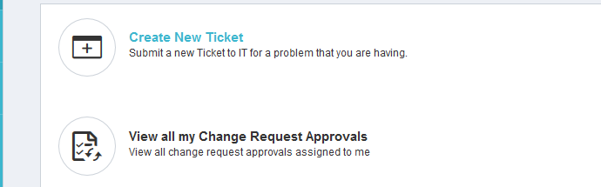

Please fill out all fields in this form Summary, Note, Priority, Type, Name and Room. We can’t help you if you don’t enter a room number! “Dave’s class” might not be helpful if your regular tech is out and has someone filling in who doesn’t know the school. Plus, your regular tech is very friendly, but they might not know where Dave’s room is and they’re too polite to say. They have a lot of schools.

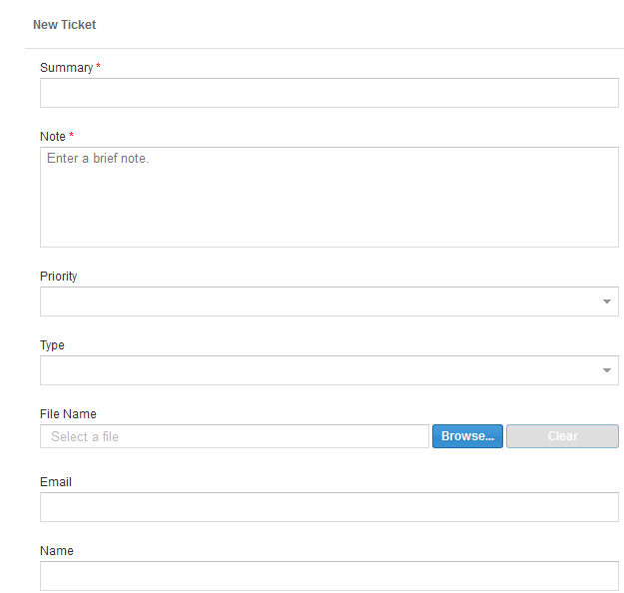
Once everything is filled out, click on Submit, and you’re done! Thanks for reading!

For IT Staff
https://helpdesk.hrsb.ns.ca/TrackIt/Account/LogIn
Sign in Example below: Select Helpdesk in the drop down list

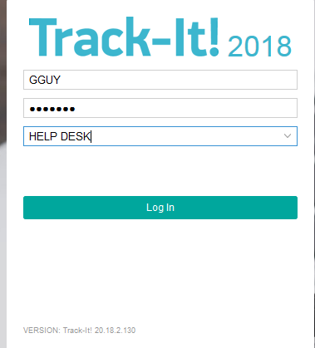

When you sign in you will select My Open Tickets in the drop down list at the top left of your screen. Then double click on the ticket.

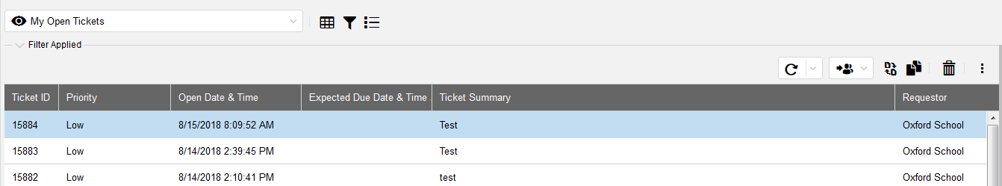

On this screen you will see a description of your ticket you can add information in the Note section if need before closing your ticket.
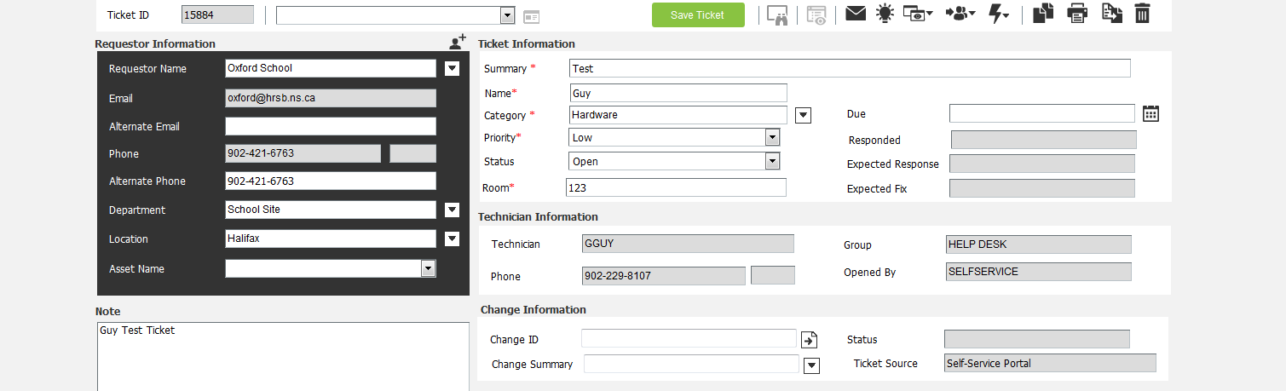

On this screen you will see a menu bar top left and to close your ticket after completing request click on the lightning bolt drop down list and select close ticket description below:

Some of you may see tickets that are highlighted in red in your queue when you log in this is because from the migration process tickets from Trackit 11.4 migrated over to the new Trackit 2018.

For teachers
https://helpdesk.hrsb.ns.ca/TrackIt/selfservice/Account

Guy Guy
Halifax Regional Center of Education
I.T. Helpdesk Administrator
902-464-4357

