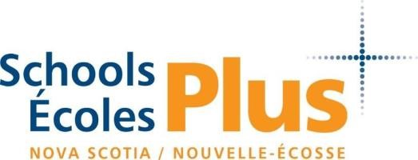

Who Are We?
SchoolsPlus is a confidential, free service available in every school in Nova Scotia! Our goal is to build positive relationships between families, schools, and communities. We can help students with what they need to succeed – from home, to school, and back again! Our team can help with things like:

Connecting to Resources & Supports

Help finding and applying for recreation programs | Help navigating various tutoring supports | Help accessing food banks or other food supports | Help navigating health & mental health services

Help filling out applications & paperwork | Help with transportation to appointments | Meeting with families at home to discuss supports | Accompanying families to important appointments

Group Programming
Our staff can offer group programming for students as well as for parents/guardians. This includes lunch time and after school programs, as well as some full-class presentations. Some examples of past programming include: parent coffee hours, social skills groups, healthy relationships programs, and more!

Managing Complex Situations
Sometimes students and families are already connected to many services, but still need help managing it all. Our Assistant Leaders can offer case management support to help make sure everyone involved is communicating clearly and families are receiving the best support possible!

How Do I Get Referred?
School Referrals | Principals, Vice Principals, or School Counsellors can submit referrals after discussing SchoolsPlus with a student or family.
Community  Referrals | Staff from various community organizations (such as IWK, Community Services, a Family Centre, etc.) can make referrals by contacting the Assistant Leader.
Self Referrals Families and students can refer themselves by contacting the Assistant Leader for their school.

Our Team

The Eastern Passage Family of Schools is served by 1 Assistant Leader (AL) and 2 Community Outreach Workers (SPCOW). Not sure if we can help? Contact the Assistant Leader for your school to find out!

Assistant Leader:  Sarah Morris  (902) 399-8321  Sarah.morris@hrce.ca | SPCOW  Samantha Galvin | Ocean View Elementary
 |  | Horizon Elementary
 |  | Seaside Elementary
 | SPCOW  Lynne McKenzie | Eastern Passage Education Centre
 |  | Island View High

NEW Ocean View Community Closet

SchoolsPlus at Ocean View Elementary has opened up a Community Closet for families to shop for clothing and shoes. Our Community Closet has new and gently used donations in a variety of sizes. Families can come in every Wednesday to browse and shop. There is no requirement to be involved with SchoolsPlus to utilize the service.
For an alternate time, please call or text SchoolsPlus to make arrangements.

COMING SOON Ocean View Community Pantry

This project is underway and we are hopeful to have the Community Pantry open by November. Stay tuned!

